**Graphic Design Notes**

**Graphic Design Fundamentals:**

1. **Color Theory:**
   * **Color Wheel:** Helps create harmonious color combinations and understand color relationships.
   * **Primary & Secondary Colors:** Primary colors (red, yellow, blue) are fundamental; secondary colors (orange, green, purple) come from mixing primary colors.
   * **Warm & Cool Colors:** Warm colors (red, orange, yellow) evoke energy; cool colors (blue, green, purple) are calming.
   * **Color Harmony:** Balances and unifies colors for a visually appealing design.
   * **Color Contrast & Legibility:** Enhances readability and guides viewer attention.
2. **Typography:**
   * **Font Styles:** Convey tone and personality, enhancing readability and visual interest.
   * **Font Sizes & Hierarchy:** Create clear visual hierarchy and improve readability.
   * **Line & Letter Spacing:** Ensure text readability and visual harmony.
   * **Text Alignment & Justification:** Improve readability and create visual balance.
3. **Composition:**
   * **Visual Elements:** Communicate messages, capture attention, and support brand identity.
   * **Design Principles:** Balance, proportion, emphasis, movement, pattern, unity, variety, contrast, alignment, and repetition.
   * **Layout & Grid Systems:** Organize content and establish hierarchy.
   * **Visual Flow & Direction:** Guide viewer attention and create engagement.
4. **Visual Hierarchy:**
   * **Organizing Content:** Use size, color, and position to create visual hierarchy.
   * **Focus Points & Emphasis:** Draw attention to key messages.
   * **Guiding Viewer Attention:** Direct viewers to key information and ensure clear communication.
5. **Design Principles:**
   * **Contrast & Legibility:** Enhance visual clarity and guide attention.
   * **Alignment & Consistency:** Create visual flow and establish a cohesive look.
   * **Repetition & Unity:** Create a cohesive look and establish visual identity.
   * **Proximity & Grouping:** Organize content and guide attention.
   * **White Space & Simplicity:** Improve readability and guide attention.
6. **Design Tools:**
   * **Adobe Photoshop:** Essential for raster graphics editing.
   * **Adobe InDesign:** Industry standard for page design and layout.
   * **Adobe Illustrator:** Essential for creating vector graphics, logos, and illustrations.
7. **File Formats:**
   * **Raster Images (JPEG, PNG, GIF):** Ideal for digital displays and vibrant colors.
   * **Vector Images (AI, EPS, SVG):** Scalable and editable, ideal for logos and illustrations.
   * **Document Formats (PDF, INDD):** Ensure compatibility, file integrity, and security.
8. **Design Process:**
   * **Research & Understanding the Brief:** Provide clear direction and ensure effective communication.
   * **Sketching & Conceptualization:** Generate and refine ideas.
   * **Design Development & Refinement:** Iterate and improve designs.
   * **Feedback & Iteration:** Refine work and ensure client satisfaction.

**Principles of Design:**

1. **Balance:** Distribution of visual weight (symmetrical, asymmetrical, radial).
2. **Proportion:** Relative size and scale of elements.
3. **Emphasis:** Creating focal points to draw attention.
4. **Movement:** Path the viewer’s eye takes through the design.
5. **Pattern:** Repetition of visual elements.
6. **Unity:** Cohesiveness of elements in a design.
7. **Variety:** Use of different elements to create interest.
8. **Contrast:** Differences between elements to create visual interest.
9. **Alignment:** Arrangement of elements along a common line.
10. **Repetition:** Consistent use of elements to reinforce unity.

**Additional Considerations:**

1. **User Experience (UX) and User Interface (UI) Design:**
   * **UX Design:** Focuses on the overall experience users have with a product, ensuring it is easy to use, intuitive, and meets user needs.
   * **UI Design:** Concentrates on the look and feel of the product's interface, including layout, visual elements, and interaction design.
2. **Branding and Identity:**
   * **Brand Identity:** Creation of logos, color schemes, typography, and visual styles that represent a brand.
   * **Consistency:** Maintaining a consistent visual style across all brand materials to strengthen brand recognition.
3. **Design Thinking:**
   * **Empathize, Define, Ideate, Prototype, Test:** Steps involved in the design thinking process to solve complex problems creatively.
4. **Accessibility:**
   * **Accessible Design:** Ensuring designs are usable by people with various disabilities, including color blindness, visual impairments, and mobility issues.
   * **Web Content Accessibility Guidelines (WCAG):** Standards for making web content more accessible.
5. **Responsive Design:**
   * **Adaptive Layouts:** Creating designs that work across different devices and screen sizes, ensuring a consistent user experience.
6. **Visual Storytelling:**
   * **Narrative Elements:** Using visual elements to tell a story or convey a message effectively.
   * **Infographics:** Combining data and visuals to communicate complex information clearly.
7. **Trends and Innovations:**
   * **Keeping Up with Trends:** Staying current with design trends, technologies, and best practices to ensure relevance and innovation in designs.
8. **Printing Techniques:**
   * **Print Production:** Understanding different printing techniques, paper types, finishes, and how they affect the final design.
   * **CMYK vs. RGB:** Knowing when to use CMYK for print and RGB for digital designs.
9. **Ethics in Design:**
   * **Ethical Considerations:** Understanding the ethical implications of design decisions, including cultural sensitivity, honesty, and respect for intellectual property.
10. **Portfolio Development:**
    * **Building a Portfolio:** Showcasing a variety of work to demonstrate skills and versatility.
    * **Case Studies:** Including detailed explanations of design projects to highlight problem-solving and creative processes.

Graphic design influences our purchases with distinctive branding, clever packaging, and persuasive advertising. It also engages us and enhances our comprehension of text in websites, apps, magazines, and books.

Photoshop is the leading professional software used to optimize photographic and complex images. Illustrator is used to draw on the computer and for single-page layout for print and screen. InDesign is multiple-page layout software and is used to organize designs prior to sending jobs to print shops or developers for digital products.

Designers often use photographs to immediately communicate a message or set a tone. Illustration has a timeless quality, while photography can look dated quickly. If your project has a long shelf life, consider alternatives to photography.

Abstract images can be beneficial because they may represent many different possibilities, and the audience can choose their own interpretations.

Visual themes and the use of repetition and variation can be used to achieve cohesion, consistency, and rhythm throughout your designs. Consistency of fonts, image style, and layout provide unity and enhance comprehension of a publication.

Most places have a visual character established by factors like their climate and architecture. Designers use these traits when creating environmental graphics, such as signs, wayfinding systems, and banners. Environmental graphics are physical, rather than digital, and have an impact on real life.

In Photoshop, areas of an image may need to be selected before you can change them. There are three primary tools for selecting. The Marquee tool selects geometric areas, usually rectangular or circular. Just below is the Lasso tool, which can select organic shapes. Next is the Quick Selection tool; however, when you hold the mouse button down, you can select the more professional Magic Wand tool, which detects similar colors and groups them into a useful selection.

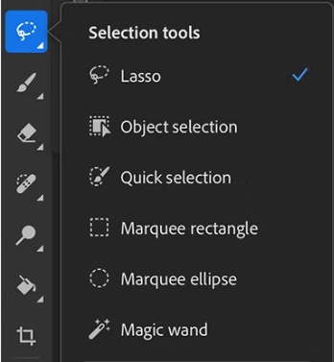

The crop tool is used to permanently change the image format. The very helpful Eyedropper selects colors from a photo to be used elsewhere, such as in text.

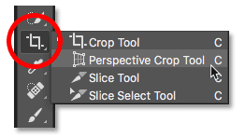

The Clone tool looks like a rubber stamp and has impressive copying capabilities, use this tool to make professional-quality image edits.

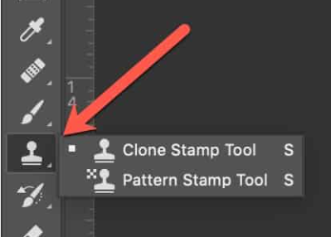

The Paint Bucket hides behind the Gradient tool and is handy for filling areas with a color.

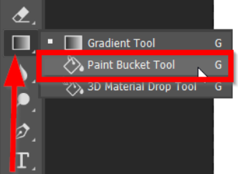

The Dodge and Burn tools lighten or darken the exposure of specific areas of a photo. By applying Dodging and Burning to selected areas of an image, you can lighten or darken them.

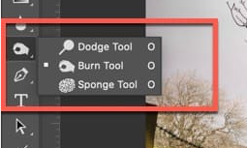

All the tools have custom settings that are displayed in the Options bar (at the top of the window) or the Properties panel (on the right).

At the bottom of the toolbar, the color squares functions are unique to Photoshop. On the top is the Foreground Color, the lower square is the Background Color. The selector allows you to quickly change to default colors; the bent arrow is used to switch the foreground and background colors.

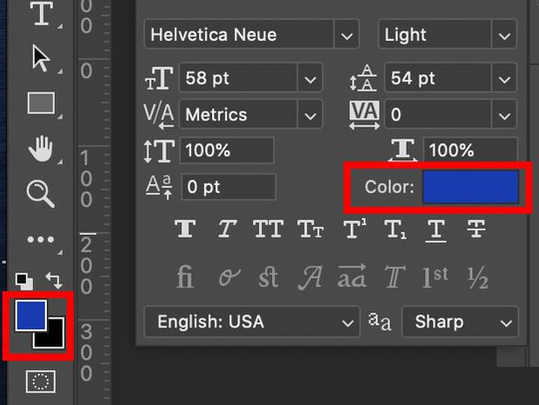

Multiple layers allow you to make changes to specific areas of your image without affecting other areas. A new layer is created every time you paste an object or add text to a file. This allows you to edit images and format text or apply transparency (or other effects) to certain layers only. The layer is active when it appears highlighted or gray. View or hide specific layers by clicking the eye icon in the left-hand column of the window.

Logos require simpliﬁed forms for effective recognition, recall, and reproduction.

Designers manipulate any or all of the elements of design when developing projects. An element is one of the simplest principles of an area of study. In graphic design, the seven elements are: color; direction; line; size; shape; texture, and value.

1. Color

Color is the use of hue, saturation, and brightness to create visual interest and convey meaning. It can be used to draw attention, evoke emotions, and create harmony or contrast. Colors can be warm (red, orange, yellow) or cool (blue, green, purple), and can be combined in various ways to create different effects.

2. Direction

Direction refers to the visual flow or movement in a design. It can be created through the use of lines, shapes, and other elements to guide the viewer's eye through the composition. Direction can be horizontal, vertical, diagonal, or curved, and can help create a sense of energy, movement, or tension.

3. Line

Lines are continuous marks made on a surface by a drawing tool. They can vary in width, length, direction, and curvature, and can be used to define shape, create texture, and convey movement or direction. Lines can be straight, curved, diagonal, or zigzag, and can be thick or thin.

4. Size

Size refers to the relative magnitude of elements in a design. It can be used to create hierarchy, emphasize importance, and create visual balance. Size can be used to draw attention, create contrast, and guide the viewer's eye through the composition.

5. Shape

Shape refers to self-contained areas with height, width, and depth. They can be geometric (squares, circles, triangles) or organic (free-form, irregular), and can be used to create form, texture, and pattern. Shapes can be combined, overlapping, or nested to create complex forms and compositions.

6. Texture

Texture refers to the surface quality or "feel" of an element or design. It can be visual or tactile, and can be created through the use of lines, shapes, and other elements. Texture can add depth, interest, and emotion to a design, and can be used to create a sense of realism or abstraction.

7. Value

Value refers to the lightness or darkness of elements in a design. It can be used to create contrast, hierarchy, and visual interest, and can help guide the viewer's eye through the composition. Value can be used to create a sense of volume, depth, and dimensionality, and can be manipulated through the use of shading, gradations, and other techniques.

An example of how shape is used in graphic design: the lines used in this ad are based off of the markings on basketball courts. It also makes use of energetic pictures and color to draw the audience’s attention.

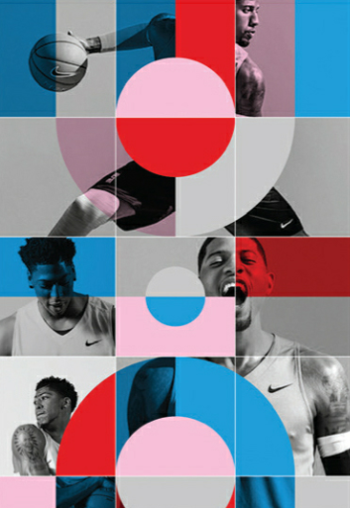

Light values of colors are called tints and dark values are called shades.

Graphic designers sometimes use tactile effects—real textures—to add unique qualities to designs. Even a simple picture, like the one below, can convey a sense of texture to the observer.



Color can elicit a sense of emotion in graphic design. The list below identifies the sentiments associated with each color.

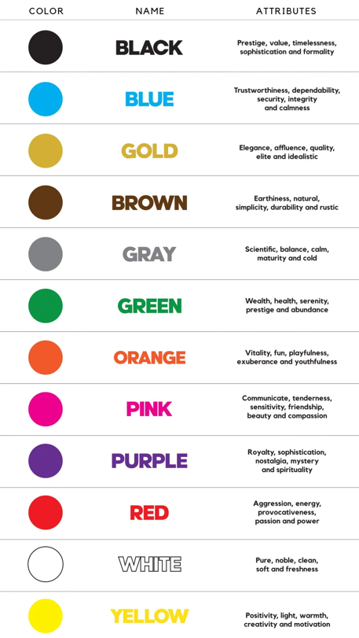

Color theory focuses on the three primary colors (red, yellow, and blue) and the secondary colors (orange, green, and purple).

**The Color Wheel**

* A circular representation of colors, showing how they relate to each other.
* Primary colors (red, yellow, blue) are equally spaced from each other.
* Secondary colors (orange, green, purple) are created by mixing two primary colors.

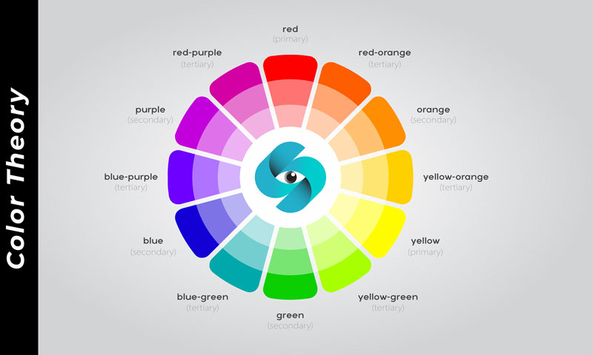

**Color Harmony**

* Refers to the way colors work together to create a visually appealing effect.
* Principles of color harmony include:
  + Complementary colors (opposite each other on the color wheel)
  + Analogous colors (next to each other on the color wheel)
  + Triadic colors (equidistant from each other on the color wheel)

CMYK colors are vital in graphic design for printing, ensuring accurate color representation, consistency, and efficiency. They enable a wider color range, reduce ink usage, and produce a professional finish, making them essential for commercial printing applications.

RGB colors are essential for digital graphic design, ensuring vibrant colors on screens, flexibility in design software, and consistency across digital platforms, making them ideal for web, digital art, and video production.

In Adobe Illustrator, Pantone refers to a standardized color system used in printing, ensuring consistent and precise color representation, especially in branding and logos.

Adobe Illustrator’s toolbar has this layout:

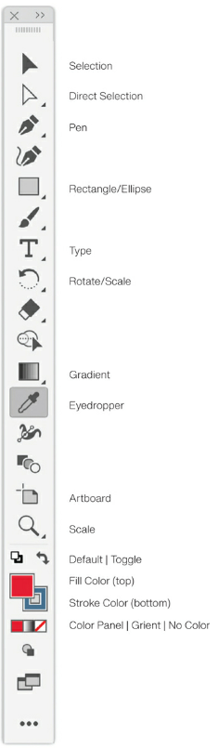

The selection tool is often the most used, and can be employed to select either one objects or many.

Some tools have a black arrow toward the bottom right. This signals that there are other tools that can be selected beyond the main tool shown as the icon. Holding the mouse button down when clicking on these icons will reveal additional tools.

The white arrow is the Direct Selection tool. It is used to select a particular point on an object to make precise adjustments to graphics. The Pen tool will initially be challenging, but fun and rewarding, once you’ve had a bit of practice. It is used for drawing.

The Rectangle tool has important variations, including the Ellipse and Line tools. The Type tool generally works in the same way as most type tools in word-processing software.

The Path Type tool for flowing text along any sort of line such as circles, waves, or an illustration and is another tool available under the type tool.

The Gradient tool ﬁlls shapes with variations of chosen colors. The Eyedropper tool is useful for identifying objects’ specific hues. The Artboard tool allows you to customize the size of your design file.

The “Essentials Workspace” is the default tool environment in most adobe applications. In Illustrator, it can be selected by going to Window>Workspace>Essentials.

The two large color squares in the toolbar are the Fill and Stroke colors. The color on top is the Fill color. The color below is the Stroke (outline) color. The bent arrow toggles between Fill and Stroke colors. To choose new colors, double-click on the either the Fill or Stroke square to open the Color Picker window.

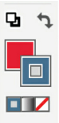

You can do unlimited undos in Illustrator.

Hue, simply stated, is the name of the color. Saturation can be thought of as the intensity of the color. Also referred to as chroma, it indicates the amount of gray in a color. Highly saturated colors are referred to as bold or true. Brightness is the amount of white in a color. Brighter hues appear in the upper left of the Color Picker square and are often called tints.

A tiny triangle with an exclamation point sometimes appears next to the current and previous color rectangles to indicate that the current color is out of gamut. In Adobe Illustrator, a gamut is the range of colors a device or medium can accurately display or print. Defined by color models like RGB, CMYK, or PANTONE, Illustrator's gamut warnings and soft proofing help designers work within these limitations, ensuring accurate and predictable color representation in their artwork. When a color cannot be displayed on a device, it is out of gamut.

Now deprecated, web-safe color palettes acknowledged that while your monitor may have been capable of displaying millions of colors, web browsers displayed only 216 colors consistently. Significant to website design, a six-digit hexadecimal number was used to specify color. Website software such as CSS defined colors using the hexadecimal (sixteen-character 0–F) numbering system. The hexadecimal value for white is FFFFFF, black is 000000, and one of my favorite blues to use for websites is 006699.

The illustration below shows key terms that will aid your ability to combine typefaces effectively and design layouts. The terms labelled within the gray lines are essential for novices.

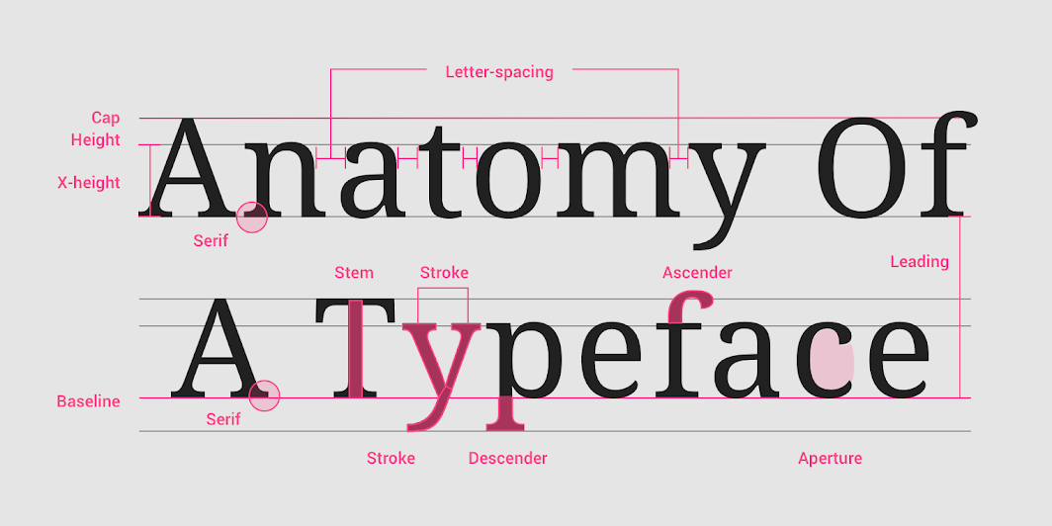

Typeface refers to the overall character set of a particular design. Font refers to the complete set of characters in any given size and style.

Serifs are the notches at the ends of letterforms. A typeface without serifs is called sans serif.

Old-Style refers to typefaces with characteristics that were typical when metal type printing was adopted in Europe. Use Garamond, Palatino, and other Old-Style typefaces when your page design needs to achieve an overall uniform appearance.

Transitional typefaces have more refined forms than Old Style ones, with more contrast and deeper bracketing to the serifs. Use Transitional typefaces for readability and subtle elegance.

The Modern letter style is characterized by a distinct contrast between the thick and thin strokes and hairline serifs abruptly set at right angles to the stems. Use Modern typefaces for their cool, crisp appearance. This style is not the best choice for large amounts of copy—the extreme contrast between the thick and thin strokes creates an overall irregular appearance on the page.

Slab serifs are a type of serif font characterized by thick, block-like serifs, often used for headings and display text due to their high legibility and attention-grabbing appearance. In your page layouts, try Slab Serif titles combined with sans-serif body copy for a clean yet dynamic page appearance. Slab Serif fonts are wonderful to use for digital products, such as apps and websites, because Slab Serif fonts are mono-weight—the thickness of each letter is consistent, and this is beneficial for digital displays.

Sans-serif typefaces have a more casual style than serif typefaces, yet they are usually just as legible. Sans-serif typefaces, such as Myriad, are frequently used for online text. Websites, email, and text messaging are often produced with sans-serif typefaces because their mono-weight lines result in better legibility on computer screens.

Scripts appear to be hand-drawn, often suggesting calligraphy. Commonly used fonts include the elegant Snell, sassy Zapfino, heavier Viktor, and friendly Renata. Tips for scripts: Avoid using all capital letters with scripts, and limit their use to small amounts of text, not entire paragraphs.

While they add a distinctive, immediate voice to your designs, many novelty letters can be difﬁcult to read. With their unique shapes and embellishments, these fonts are not necessarily concerned with legibility.

Rather than simply providing information, fonts can also provide immediate emotional expression.

Start with a decision about the attitude and tone of your design. Then search for one or two typefaces that match the desired mood. Details, weight, and height create character. Heavy and bold suggests immediacy, while serifs can feel conservative, and thin serifs will look somewhat similar—as well seem classical. Sans serif fonts often convey more contemporary or casual tenors. The right typeface sets the proper tone for your design and helps establish a voice for your copy.

A classic approach to selecting typefaces is to use two fonts in each design: one for titles and one for the body copy—one serif, one sans serif.

Try to use typefaces that have the same x-heights when combining two typefaces. In this way your design will achieve an elegant unity.

A type family contains all the variations of a particular typeface. Superfamily typefaces contain both serif and sans-serif versions.

Computer software has the ability to make changes to these carefully designed letters. Just because the software makes distortions possible, it doesn’t mean we should indulge.

Typefaces that are trendy can make your design look dated quickly: consider the life span of your project when choosing the typeface.

Justified type refers to lines of text in which all the lines are the same width.

A general guideline is to make your columns forty-five to seventy-five characters wide. Counting letters and spaces, sixty-six characters is considered ideal. For multiple columns, use forty to fifty characters.

Left alignment is very commonly used in websites, magazines, annual reports, packaging, and captions. This format has a more informal appearance than justified copy. It is also called flush left and ragged right.

Right alignment aligns the text along the right axis. It is most unusual in paragraph form because it is difficult for the eye to keep searching for the beginning of each line. It is best reserved for titles or a group of lines that help to balance a page layout.

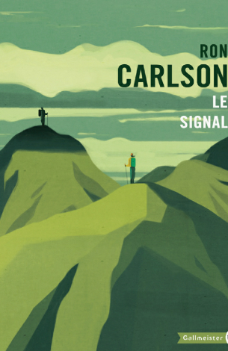

Centered copy is best used for title pages, invitations, and small amounts of copy. Be aware that some development software for responsive websites may only allow centered text.

Asymmetrical formats are used in designs to make dramatic statements. Each line, word, or letter is placed in a unique position. This format is sometimes used with elaborate typefaces to achieve better balance among letterforms.

Contour formats follow a shape or image. This technique grabs attention. The trick is to keep the margins between the shape and text consistent.

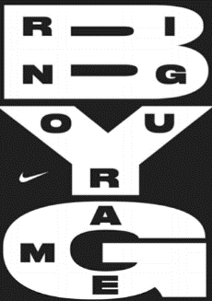

The Pen tool in Illustrator will initially be challenging, but it is fun and rewarding once you have had a bit of practice. It is used for drawing.



The Direct Selection tool is used to select a particular point on an object for making precise adjustments to drawings. Keep in mind, the black Selection tool selects an entire object with many points.

The Type tool generally works in the same way as most Type tools in word-processing software. However, when you put your cursor over the Type tool, then press and hold the mouse button, you’ll see variations.

Designs use photographs and illustrations to get our attention, and only then, after we’ve been hooked, do they provide information. A well-chosen image communicates on multiple dimensions: subject, mood, issue, humor, and/or information.

Illustrators can eliminate details and can have a timeless quality compared to photographs. Photographs, particularly when they include people, may look dated quickly because of changes in fashion. It’s not just clothing—hairstyles, makeup, even moustaches—can date an image. If your product will have a long shelf life, consider using illustration.

The line between illustration and photography has blurred due to the capabilities and widespread use of digital photo-editing software.

Until recently there was a longstanding trust in photography. Prior to affordable desktop photo-editing software, most people believed photographs could not lie—photos were considered factual records.

Because aspects of a photography can be changed due to photo-editing software, it is important to first ask yourself whether changing a particular image is ethical.

The cellphone revolution has resulted in a steady uptick in the number of images available. The popularity of collages as a medium have thus increased.

As digital-image resolution increases, image quality improves, but file size grows too.

The typical resolution values you’ll see are 72 dpi and 300 dpi. Dpi, an abbreviation of dots per inch, refers to the number of dots of ink on printed paper. When printing, more dots of ink per inch create sharper images: there are typically 300 dots of ink per inch. Resolution refers to the dpi number and indicates the sharpness of the photo. We call 72 dpi low-res (low resolution) and 300 dpi hi-res (high resolution).

In general, digital images will be 72 dpi for screen displays and 300 dpi for printed publications. For consistently high-quality image reproduction, print designers typically work with 300 dpi images.

Get into the habit of starting each project with a folder, and place all your images and your software file into the same folder. This way, your images will be linked to the file, and will always display or print at their best quality.

TIFFs are used for high-quality images that are to be printed. TIFFs are large files and usually uncompressed. The term “uncompressed” means none of the original image data is eliminated to make the file smaller when saved in this format.

A less common format is EPS files, which are also uncompressed and used for high-quality images.

JPEGs are used for photographs and complex illustrations intended for screen displays. This is the most common compression file format. File compression results in smaller file sizes, but it eliminates some details and colors. JPEG files can be saved with low, medium, and high quality. High-quality JPEG files will eliminate less information, but the file size will be bigger. When JPEGs are saved at 300 dpi and maximum quality, they can be printed.

GIFs are low-res, compressed file type for screen display only. GIFs are used for text, logos, and charts on digital designs, such as websites and apps. GIF compression eliminates variations of colors to reduce the file size. GIFs are great for graphics that have few colors. The menu graphics on my website are saved as GIFs. Don’t save photographs as GIFs because the compression will reduce smooth gradients to bands of colors.

PDF files accurately display all the characteristics of a design, even unique typefaces, without requiring the original software or fonts to be on the recipient’s computer. They are used for sending designs via email, for large graphic and text documents that are available on websites, and for cost-effective printing. PDFs can be compressed with low, medium, or high quality for screen or print.

A general guideline is if the dimensions are over 1,000 pixels, the image quality is good enough for research.

Royalty-free images are not fee-free. There is a one-time cost for the use of the image in accepted ways, forever. The cost is cheaper than rights-managed images because the photographer or agency holds the copyright and the designer is paying for the right to use the image.

300 dpi images can be increased up to about 120 percent, before they begin to lose clarity.

For educational purposes, image copyright restrictions are generally suspended for class projects. Any time your work is intended for commercial purposes or profit, you must acquire image rights and pay for copyrighted images.

Avoid cropping too closely with your camera’s viewfinder. The photo may not have the same proportions as the final design, and it’s often helpful to have large margins on all sides. Also, it’s generally best to put the light source behind the camera when taking photos.

Cropping in a photo-editing program is used to modify the focal point and ensure which area attracts attention. Be careful: once an area has been cropped and saved, there is no way to restore the information that was cut out. Backups of original photos can help in that instance.

Sometimes, several photos are used in one piece. The visual cohesiveness is preserved by using a limited color palette. Common colors- and sometimes uniform spacing, gives the impression that even if subjects are somewhat different, they are related to one another.



A traditional photography composition strategy is called the “Rule of Thirds.” This proposes that you envision three columns across, and three rows down a photo. Place major vertical features into the columns, horizontal features into the rows, and the focal point near an intersection of the lines.

In photoshop, it is a good idea to open the “image size” box to look at a picture’s dimensions and dpi prior to editing. You can do this by clicking Image>Image size.

When you have a high-resolution original file, and plan to use only low-resolution files, always save the original for the length of the project.

Dodging lightens an area of an image. This tool can be used to show more detail in a particular area of a photo.

To compare versions of a photo after an edit has been made, use the History window. Open this by clicking Window>History. By unselecting the effect and reselecting it, your photo will change between what it was before and after the effect/edit was done.

The Burn tool makes part of an image darker. When text appears above a photograph, designers use the Burn tool to make the area behind the letters subtly darker. The words over the photo are then easier to read because the image is generally darker with less value change.

The Dodge and Burn tools use default colors to make the adjustments. You can customize these using colors from your photo for even more realistic results. Select the Eyedropper tool and click on a very dark area of the photo. Use the bent arrow above the colors to put the dark color in the lower square. Now click on the upper (foreground) square. Click the Eyedropper on a very light area of the photo. Now the tools will use those colors as the basis for darkening or brightening.

An effective path layout leads our eyes through the entire design. Layouts can engage the audience and subtly guide them through essential elements.

There are two different layout strategies that create effective graphic design: the path and the grid.

In a path layout, the designer skillfully arranges objects on the page so the audience’s eyes are brought through all the contents in a meaningful sequence. This is a particularly effective approach for single-page designs, such as home screens, advertising, and posters.

The focal point is the part of a layout that pulls the audiences eyes to itself. Color and size are two popular methods utilized by graphic designers to pull the viewer’s attention to a particular place. Focus can also be used for defining a focal point by making the focal point sharp, and other areas fuzzy. Also- white space can be used to draw the eye to anything which breaks up that space.

Visual hierarchy also plays an important part in guiding the eye to other details. While the focal point might pull us in initially, the balance of the design below carries our eyes to the right to then absorb the information presented there (also- think about how our brain typically reads from left then to right).



Place your main text near the focal point, or along the path, to integrate the text with the image. There are many ways to establish a good focal point, but remember it’s part of a whole. If it’s too strong, the reader will stop there and miss the rest of the design’s content. Repetition of colors, shapes, and textures also creates flow.

Repetition of colors, shapes, and textures also creates flow. Readers will subconsciously understand via your design choices where to look first, second, third, and you will lead their eyes through the important content of the design.

Make thoughtful visual hierarchy decisions while designing with text. Establish an effective focal point, integrate the type with the image, establish visual hierarchy of information, and you will achieve an engaging and easy-to-comprehend design.

Adobe InDesign is primarily used for multiple-page layouts. It is also great for organizing images and preparing files for professional printing.

You will use Photoshop to optimize your photographs and Illustrator to create logos, drawings, and single-page designs. But InDesign is essential software for multiple-page, text-heavy publications, and preproduction organization.

InDesign’s tools look very similar to Illustrator’s. However, InDesign’s frames provide structure for the placement of images and text. Yes, you can simply place images and text into a document, but when position is key, frames are important, and when document layouts are used repeatedly, frames are fabulous—copy and photos can be changed in the frames, and the layout stays the same. When you press and hold on the Rectangle Frame tool, you’ll see it also provides elliptical and polygonal options. Notice the Frame tool looks like the Rectangle tool with an X inside.



An important distinction arises with Frames and Selection tools in InDesign. Use the black Selection tool to adjust the frame (size, position, etc.). Use the white Direct Selection tool to adjust the photo (size, crop, etc.) inside the frame.

The Color Theme tool makes color suggestions based on images in your file. When you click on an image with the Color Theme tool, the software provides a coordinating color palette. If you want to use these colors, simply click on the + Swatch icon to add the suggested colors to your file’s swatches. Access the color Swatches panel by selecting Window > Color > Swatches. Your new Colorful Theme will appear at the bottom of the swatches window.

From the new document option screen, it’s possible to turn off “Facing Pages” (this setting is useful for double-page spread projects such as magazines).

“Full Bleed” is when an image goes to all four corners of a document. “Bleed” refers to the ink that extends beyond the borders of the design, and the edges must be trimmed after printing to produce these pages. Designs that are not full-bleed are often cost-savers because they can be produced without trimming the edges, reducing paper and production expenses.

Centered layouts are symmetrical; all the elements are arranged equally on both sides of the design.

In asymmetrical layouts, designers place dissimilar elements unevenly—yet still achieve balanced results. Though the image may be more on one side of the page and the headline and supporting copy on the other side, the design has an overall balance. This approach is more challenging than the symmetrical layout, but it is also more visually compelling.

To achieve asymmetrical balance, consider every position, weight, size, value, color, shape, and texture of each object. A balanced design seems to hold together and feel natural. An unbalanced design makes the viewer uncomfortable.

When creating a layout, place all the elements on the page in such a way as to achieve a relationship based on visual hierarchy and balance.

Gestalt theory helps us understand human visual perception. Gestalt principles related to graphic design include proximity, similarity, continuity, closure, and figure/ground. When you follow these principles, your designs will appear more coherent and complete.

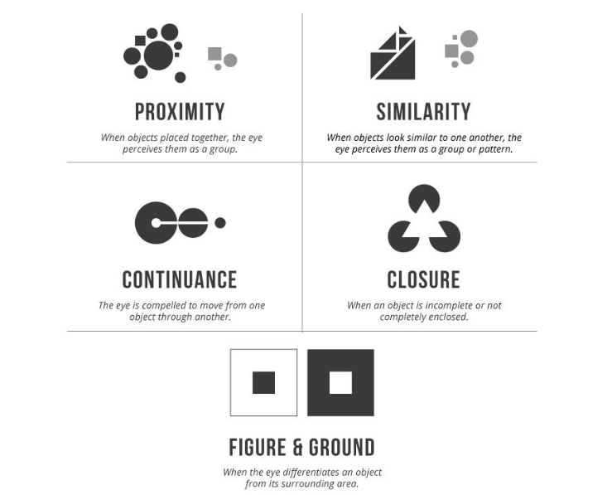

The golden ratio is an irrational mathematical constant used in graphic design layouts to create aesthetically pleasing compositions through balanced, harmonious proportions believed to be naturally appealing to the human eye, though its application is subjective. The golden spiral is a spiral curve that gets wider based on the proportions of the golden ratio. It visually represents the pattern of the golden ratio expanding outward. In design layouts, the golden spiral can be used to position elements in an aesthetically pleasing, natural-looking flow. Examples of application shown below:

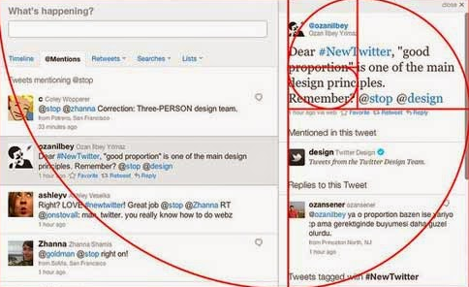

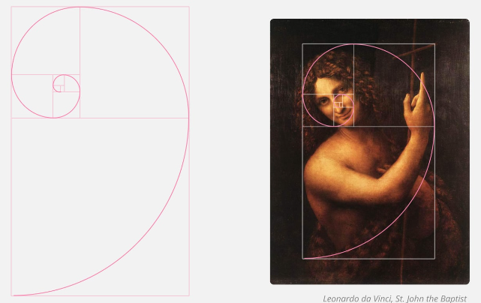

The gestalt-related principle of unity means that all the elements on a page look like they belong together. The best approach is to ensure that each object has a relationship with another object on the page. You can do this with alignment, or create visual connections using color, line quality, direction, size, shape, texture, and/or value.

A grid layout in graphic design is a two-dimensional structure of intersecting horizontal and vertical lines that divides the space into rows and columns. It provides a rational framework for organizing and aligning text, images, and other visual elements in a consistent and orderly manner. The grid ensures proper spacing, hierarchy, and visual flow as elements are positioned according to its modular structure. By following the same underlying grid, designers can create cohesive layouts with visual continuity across multiple pages or screens. Grid layouts are a fundamental tool that brings structure, logic, and intention to the placement of content in print, UI/UX, and web design.

Grid structures are based on the overall page format and an ideal column width of forty-five to seventy-five characters. The character-width guideline is based on the area of a page that readers can see at a typical reading distance without moving their head or getting eyestrain. Be wary of text columns that are too narrow. It can be difficult to format, or even read, the text.

The repetition of shapes and negative spaces brings order to the overall design.

When selecting images for a grid layout, choose images that work together as a whole. The images should have a collectively similar style or palette to be visually consistent throughout a design.

InDesign allows us to place very large Microsoft Word text documents into a file. When the amount of copy is more than one frame or column, hold the Shift key down and the copy will automatically flow or thread through as many frames as needed.

Standard paper formats and ideal column width lead to typical three/six- and two/four-column grids.

Logos express complex company personalities with very simple yet distinct designs. They identify products or organizations, convey quality, style, value, even origin.

Logos must be visually uncomplicated for three reasons: ease of recognition, recall, and reproduction.

* Recognition: the best logos are so simple; they have immediate recognition- even when only partially viewed
* Recall: the simplicity of a logo allows for ease of recollection since details take much more for us to store away
* Reproduction: logos can be reproduced in many formats, and in many ways

Some logos are revamped as time goes by- simplifying color, typography, and form for ease of reproduction.

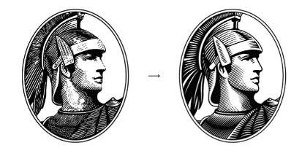

Outlined fonts often have legibility issues in smaller digital displays.

Logos also need to reproduce well in black and white.

Think of logo design as providing a complex description in a single visual statement. To be competitive in the marketplace, organizations are often diversified—they provide a variety of products, or more than one type of service. When creating a logo, designers cannot emphasize one particular aspect of a company without regard to all the others, or those parts of the business that were not featured would be poorly served. This could have negative consequences for sales.

Logotype: defined as the name of the organization presented in unique typography.

Logotypes sometimes feature initials of the company name to create more easily recognizable identities.

Alongside strong visual elements, the use of color allows a brand to appeal to audiences by tapping into personal connections that people may have to things like seasons.

Logos often combine typography with symbols. Abstract symbols are common because no particular area of an organization is favoured over another. Some abstract symbols have characteristics that allude to the general nature of the business. A good example is the Chase Bank logo:



Tangrams: geometric shapes combined to form the letters of the name.

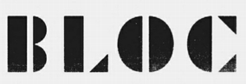

Pictorial symbols are representational. They look like the product or have an obvious association with the company’s business.

Associative symbols depict images that are not the product or service itself, but ones that have a strong relationship to the organization.



Flexible identity systems allow clients to adapt to these variations and for company growth.

Semiotics in graphic design is concerned with the use of signs and symbols for communication. These are used for many different purposes in graphic design. The flexible system of icons allows for illustrations and patterns that can be used for a variety of collateral across all media.

These five steps are suggestions for new designers to ensure successful projects—with less frustration— when initially designing logos:

1. Understand the problem: Restate the design project in your own words. State what the design is intended to communicate and to whom.
2. Get inspired: Expose yourself to art.
3. Brainstorm: generate fresh ideas and associations.
4. Sketch: seeing a draft on paper is a way to determine if a concept will be successful before you spend time producing it with software.
5. Produce: begin to produce the work with software.

Before presenting logo designs to a client or class, rehearse a brief explanation of your concept and choices. Clients are more likely to appreciate the design results when they hear how their company was thoughtfully interpreted.

When creating a logo, you’ll choose a font and color scheme, and sometimes add a symbol. All these decisions combine to identify and distinguish the company from others. An essential aspect of logo design is taking the time to analyze typefaces.

Rhythm can be established within a word by the pattern of curves and lines created by the letterforms.

A key to a good logo symbol is simplicity of form. If you want a pictographic icon, strike a balance between characteristic details and streamlined form. Always look at an example of the object while sketching—don’t trust your visual memory for details. Emphasize one or two details and simplify the rest.

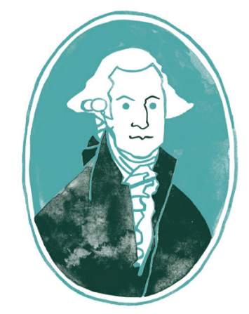

Use color to convey information about your company’s brand.

When using Pantone color swatches, choose “Small List View” (in the hamburger menu) to see each color’s number.

Websites, magazines, campaigns, books and packaging are examples in which visual themes unify the overall look. Unlike a poster or advertisement, which can be understood with a glance at one page, the entire design strategy is only revealed as the reader goes through multiple pages, screens, or formats.

Without visual themes—consistent use of typefaces, colors, image style, layout, and graphic elements—the audience can get confused.

Color choices establish an appropriate palette for a design. Choose enough colors for interest, but not too many, since this could dilute the overall impression.

Let the image content provide the variety. If the image style is very distinctive, it is difﬁcult to introduce another without disrupting the overall tone.

Visual themes are most effective when they are applied consistently throughout all media, from print to digital to tote bags to architecture.

Section titles are larger and often more colorful than subtitles, and both are larger than paragraph text. Page folios are even lighter in appearance. This strategy establishes visual hierarchy of the information, provides visual clues, leads the reader through the content, and enhances comprehension.

Visual themes can be purely visual or can be based conceptually on the content of the material. When based on content, these design choices are called editorial themes.

Visual themes can establish a rhythm throughout a publication or website. Designs can set an appropriate tempo—quick and lively for a stylish clothing website, or solemn and digniﬁed for a health organization’s annual report. The color, size, and placement of titles, and the length and width of the columns, contribute to the rhythm.

When designing with traditional media, unique papers, glosses, and embossing can convey the personality of a piece immediately. These visual and tactile characteristics make designs more memorable and therefore more likely to communicate the message.

Visual and editorial themes can be used throughout media campaigns and should be consistent across all media from print to websites to architecture.

Hanging punctuation—adjusting the position of quotation marks, periods, and other punctuation so that the letters are aligned and the punctuation “hangs” beyond the sharp edge of the lines of type.

Image banks—commercial resources for images including photography, illustration, and video.

Rebus—a visual puzzle made of a string of letters and pictures that represent sounds in place of words or syllables.

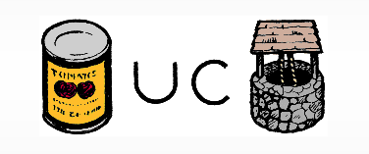

When using an image that is larger than your frame, resize by choosing Object > Fitting > Fit Content Proportionately.

All your placed images are listed in the Links window. If you rename a file or move it, InDesign will prompt you to fix the link. Open the Links panel under Window > Links. Relink by clicking on the file name, then clicking on the Relink icon in the bottom row of the panel.